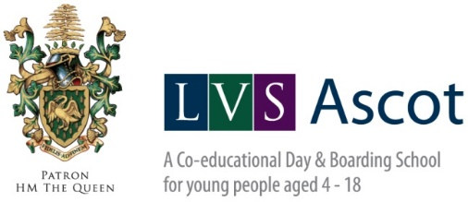

|  |  |
| --- | --- |
|  |  |
|  | **STATEMENT OF BOARDING PRINCIPLES AND PRACTICE** |
|  |  |

|  |  |
| --- | --- |
| **Relevant Statutory Regulations:** | NMS1 |
| **Nominated member of SMT responsible for the policy:** | James Wilder James Curtis-Nye |
| **Updated:** | 20 June 2022 |
| **Date of next review:** | 20 June 2023 |

The boarding community at LVS Ascot is culturally varied and diverse. We embrace others and their values, while staying true to our British values. This ensures that our school’s mission to promote resilience, inquisitiveness, and creativity in everything that our children set out to do, gets promoted within the boarding experience that we offer.

We have a significant number of UK boarders as well as our international boarders within our boarding community. Our children come from a plethora of cultural backgrounds with varying social experiences and needs. It is the stated aim here at LVS Ascot School to be able to treat all our boarders as individuals and to provide a positive, safe, and nurturing environment in which all can flourish.

**Boarding at LVS Ascot is based on the following key principles:**

* The development of the whole person, physically, spiritually, intellectually, morally, socially, and emotionally in a conducive atmosphere of positive praise and reinforcement.
* The promotion of mutual respect and the right to be treated as an individual.
* The right of the individual not to suffer any form of abuse.
* An equality of opportunities provided to all, regardless of socio-economic or cultural background.
* The right to privacy.
* Fostering supportive links with parents and guardians.

In addition to addressing the physical needs and sense of security and safety, each one of our boarding houses seeks to contribute to their boarders’ development. This is manifested in their sense of belonging, their self-esteem, self-respect, and self-realisation. House staff are and should be advocates for the boarders in their care.

Pupil voice is taken seriously at LVS Ascot, and a full programme of boarders’ council meetings are carried out across the academic year, involving a selection of boarders from across our four boarding houses. In addition, houses promote leadership qualities through their house Prefect selection process.

# Aims & Objectives of Boarding at LVS Ascot School

The aims and objectives of each boarding house will differ in practice depending on their age range and circumstance of the house, but all will seek to:

* Create a safe, secure, and comfortable environment for all our boarders.
* Provide a range of experiences, opportunities and conditions that will encourage self-development: physically, spiritually, intellectually, morally, socially, and emotionally.
* Develop an open and trusting ethos in which the boarders are confident that they will be treated with respect as an individual.
* Create an atmosphere which is non-conducive to any form of bullying or would have difficulty in flourishing.
* Develop a sense of responsibility for self, others, and the environment.
* Develop boarders’ qualities of leadership and the ability to work as part of a team.
* Encourage understanding relationships between boarders, staff, guardians, and parents.

**Aims of LVS Ascot**

* To reflect on the past to embrace the challenge of the future.
* To be resilient, inquisitive, and creative.
* To be happy and healthy.
* To live with empathy and integrity.
* To be courageous, bold, and robust in our endeavours.

